EXPERIMENT 1
Title: Responsive and Interactive UI using Tailwind CSS
AIM:
To design and develop a responsive and interactive car dealership web interface for the Carventory application using React, Vite and Tailwind CSS, including Home, Login, Inventory, Car Details and Dashboard interfaces.
THEORY:
A responsive web interface is a web application that automatically adapts its layout and elements according to the screen size and device being used. A responsive application should provide a good user experience on desktops, laptops, tablets and mobile phones.
React is a JavaScript library used for building user interfaces using reusable components. Instead of creating the complete webpage as one large section, React allows the application to be divided into smaller components. In the Carventory project, components such as Navbar, Footer, Button, Search Panel and Car Card are reused throughout the application.
Vite is used as the frontend development and build tool. It provides a fast development server and helps in creating and building the React application efficiently.
Tailwind CSS is a utility-first CSS framework. It provides predefined utility classes for properties such as spacing, colours, typography, borders, shadows, grids and responsive breakpoints. This makes it easier to create a consistent and responsive design without writing large amounts of custom CSS.
The Carventory application is designed as a used-car dealership platform where customers can browse available cars and view their details. The frontend contains different pages such as:
- Home Page – Provides the main introduction to Carventory and allows users to start searching for cars.
- Inventory Page – Displays available cars in a card-based layout.
- Car Details Page – Displays detailed information about a selected car.
- Login/Register Page – Provides the interface for user authentication.
- Dashboard – Provides the initial dashboard interface for administrative functionality.
React Router is used for navigation between different pages without requiring a complete browser page reload.
During this experiment, mock car data is used instead of a database. The purpose is to first create and test the user interface. The backend and PostgreSQL database are introduced in later experiments.
The interface is also designed with responsive layouts so that components such as car cards, navigation menus, search sections and buttons adjust according to the available screen size.
IMPLEMENTATION / WORKING
The Carventory frontend was developed using the following technologies:
- React – User interface development
- Vite – Frontend development and build tool
- Tailwind CSS – Styling and responsive design
- React Router – Page navigation
- JavaScript – Application logic
Reusable components were created to avoid repeating the same UI code. The car inventory was initially populated using mock data.
The application was tested on different screen sizes to ensure that the interface remained usable and visually consistent.
OUTPUT
The following interfaces were successfully developed:
- Carventory Home Page
- Responsive Navigation Bar
- Search Panel
- Car Inventory Cards
- Inventory Page
- Car Details Page
- Login/Register Page
- Dashboard Interface
- Responsive mobile layout

Output Screenshot:\
LOGIN PAGE:
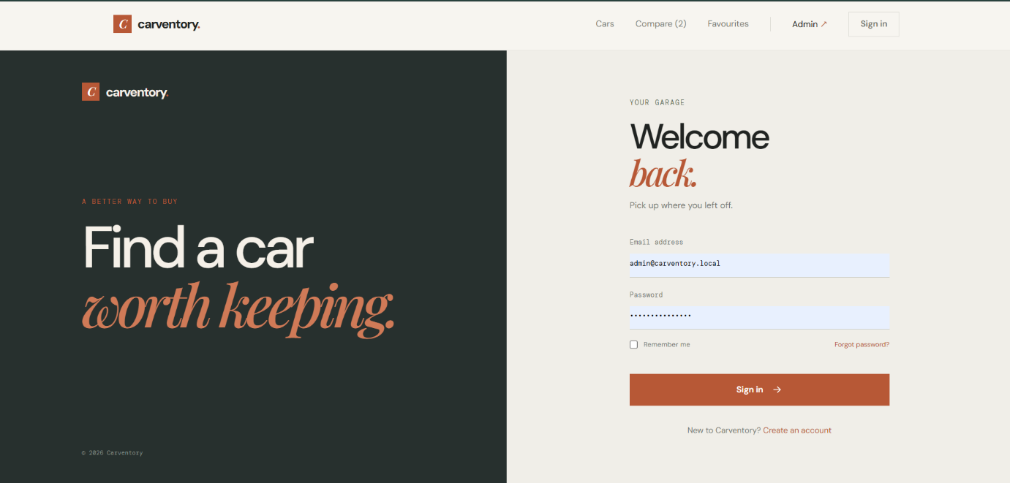
HOMEPAGE: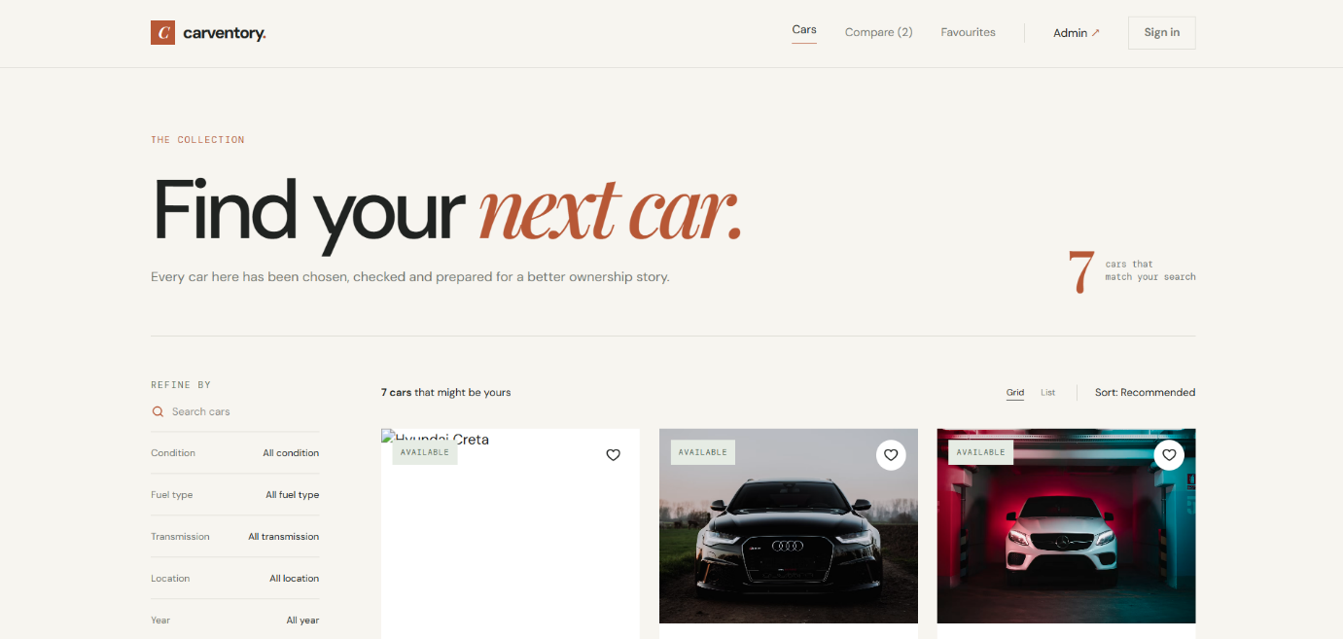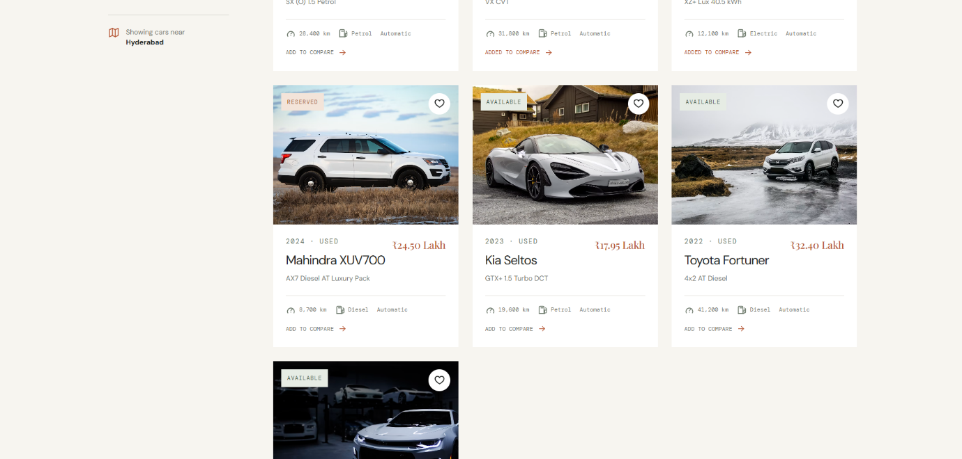
COMPARSION PAGE:
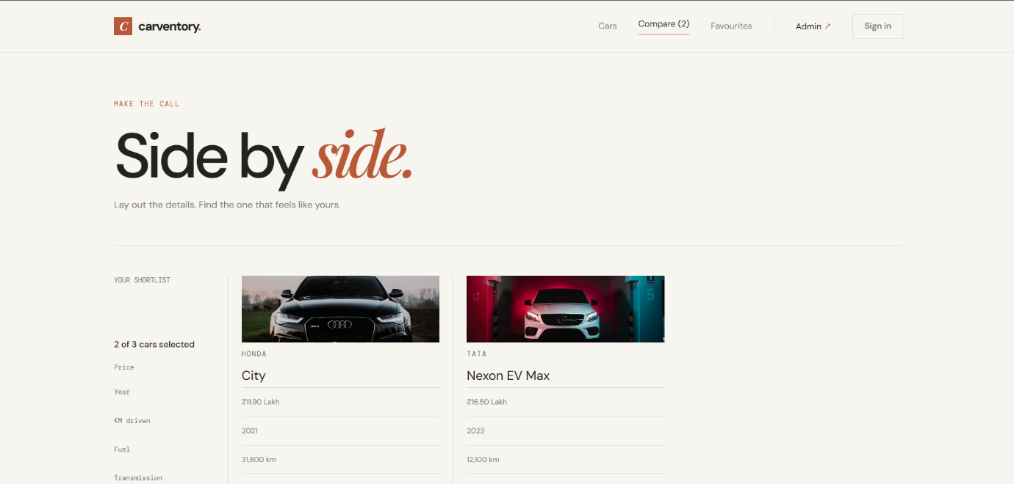

CONCLUSION
Thus, a responsive and interactive car dealership web interface was successfully developed for the Carventory application using React, Vite and Tailwind CSS. Reusable components and responsive layouts were implemented for different pages of the application. The frontend provides the basic user interface and foundation required for the further development of Carventory in the upcoming experiments.

